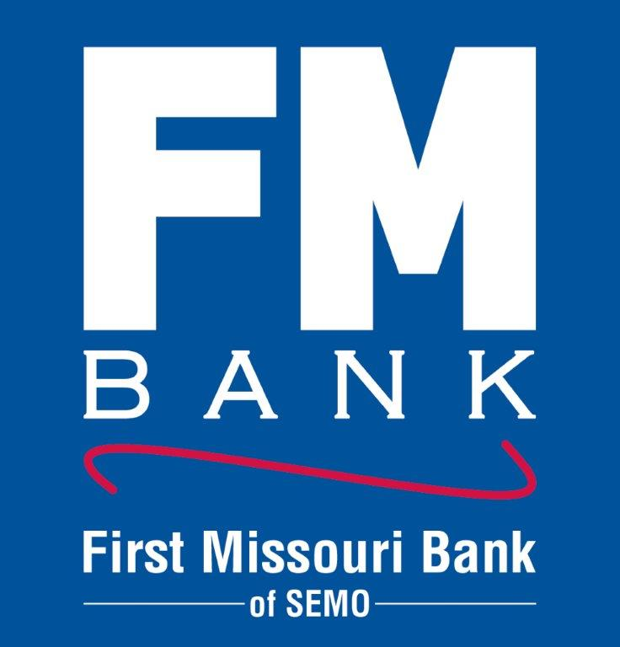

PRESS RELEASE: Business Hour Change Notice
December 9, 2022
FOR IMMEDIATE RELEASE

Due to the advancement and application of electronic banking products and services offered, First Missouri Bank of SEMO is implementing a change to banking hours at its Dexter, Missouri branch. Effective January 8th,2023, lobby and drive thru banking hours will be from 8:30 a.m. to 4:30 p.m., Monday through Friday. Hours of operation at all other First Missouri Bank of SEMO locations will remain the same.
Please remember our night drop box, ATM Machine, and online and mobile banking platforms are available 24 hours a day, 7 days a week. Enroll in online banking at www.myfm.bank and download the FM Bank mobile app for safe, convenient access to your accounts. Please contact your local FM Bank branch if you have any questions.

